SAVEETHA SCHOOL OF ENGINEERING
CSA15- CLOUD COMPUTING AND BIG DATA ANALYTICS
LIST OF EXPERIMENT 3
3) Create a simple cloud software application for Property Buying & Rental process (In Chennai city) using any Cloud Service Provider to demonstrate SaaS.
SOL
AIM:
To design and implement a simple cloud-based Property Buying & Rental System optimized for Chennai city using Zoho Creator and deploy it as a Software as a Service (SaaS) application, demonstrating dynamic relational tables via lookups, multi-user role structures, and online data handling via a web browser.
PROCEDURE:
- Sign In: Sign in to the Zoho Creator cloud platform using the registered student account credentials.
- Application Shell: Create a completely fresh standalone application by selecting the Create from Scratch option and name it SaaS Experiment 3 Property Rental.
- Form 1 (Owners Table): Design the first data entry form named Owners, adding a Name field labeled Owner Name and a Phone field labeled Contact Number. Publish and save the form configuration.
- Form 2 (Properties Table): Design the second data entry form named Properties to catalog listings, adding a Lookup Field linking directly to the Owners form (selecting Owner Name as the display value), a Drop Down menu labeled Locality in Chennai (Adyar, Velachery, T. Nagar), and a Number field labeled Monthly Rent (INR).
- Form 3 (Inquiries Relational Table): Create the third form named Inquiries to act as the relational hub connecting clients to properties:
  - Add a Name field labeled Client Name.
  - Drag a Lookup Field linking directly to the Properties form, choosing Locality in Chennai as the display index.
  - Add a Radio button field labeled Status containing progress states (Interested, Visiting, Finalized).
- Report Generation: Automatically generate clean list view reports for Owners, Properties, and Inquiries to allow instant sorting, viewing, and secure cloud search processing.
- Deployment & SaaS Access: Click on the blue Access This Application button to securely host and deploy the integrated system live onto the Zoho cloud infrastructure.
- Functional Cloud Testing: Populate the live cloud application database by sequentially inserting 3 unique sample entries into the Owners form, 3 entries into the Properties form, and executing cross-table relational tracking links inside the Inquiries form.
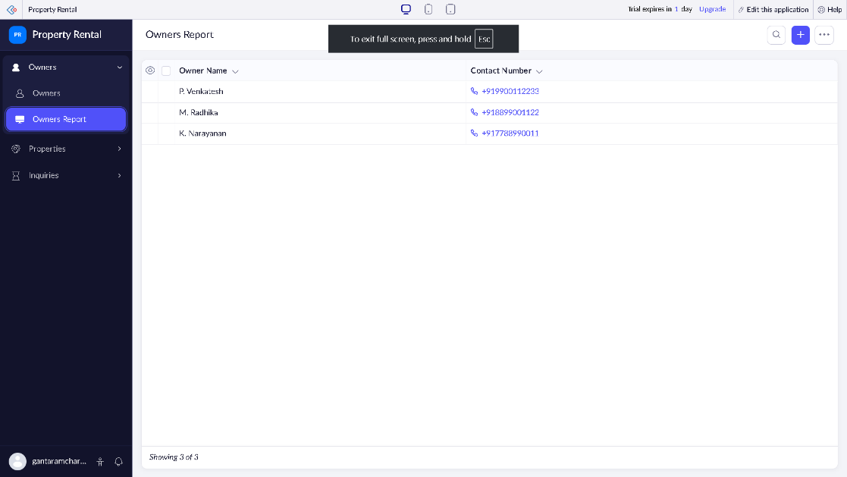
SNAPSHOTS:

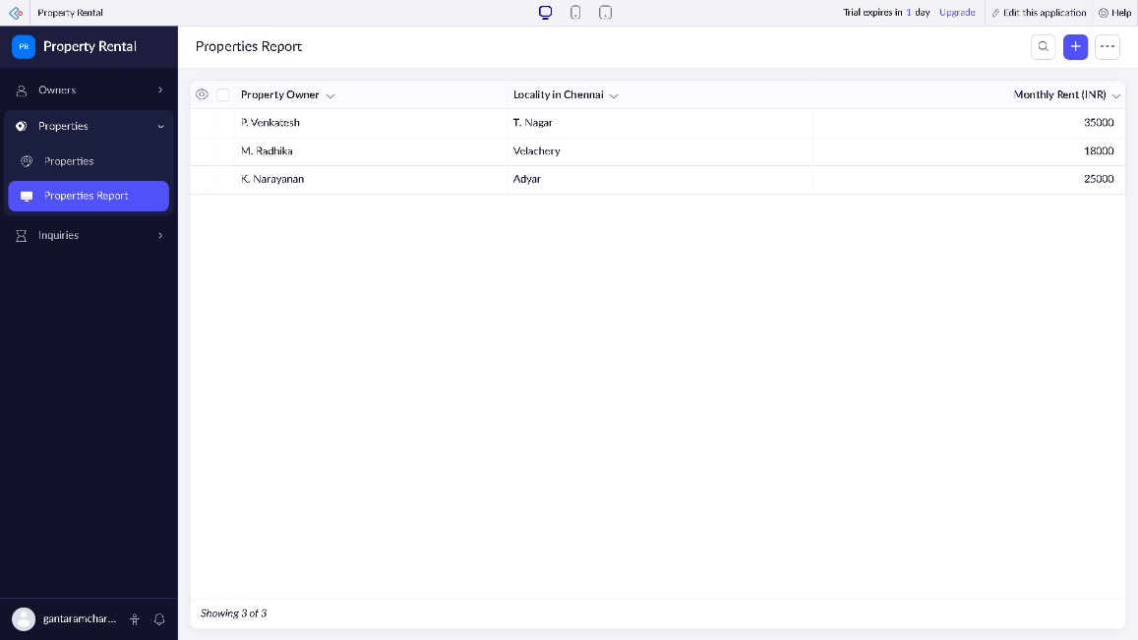

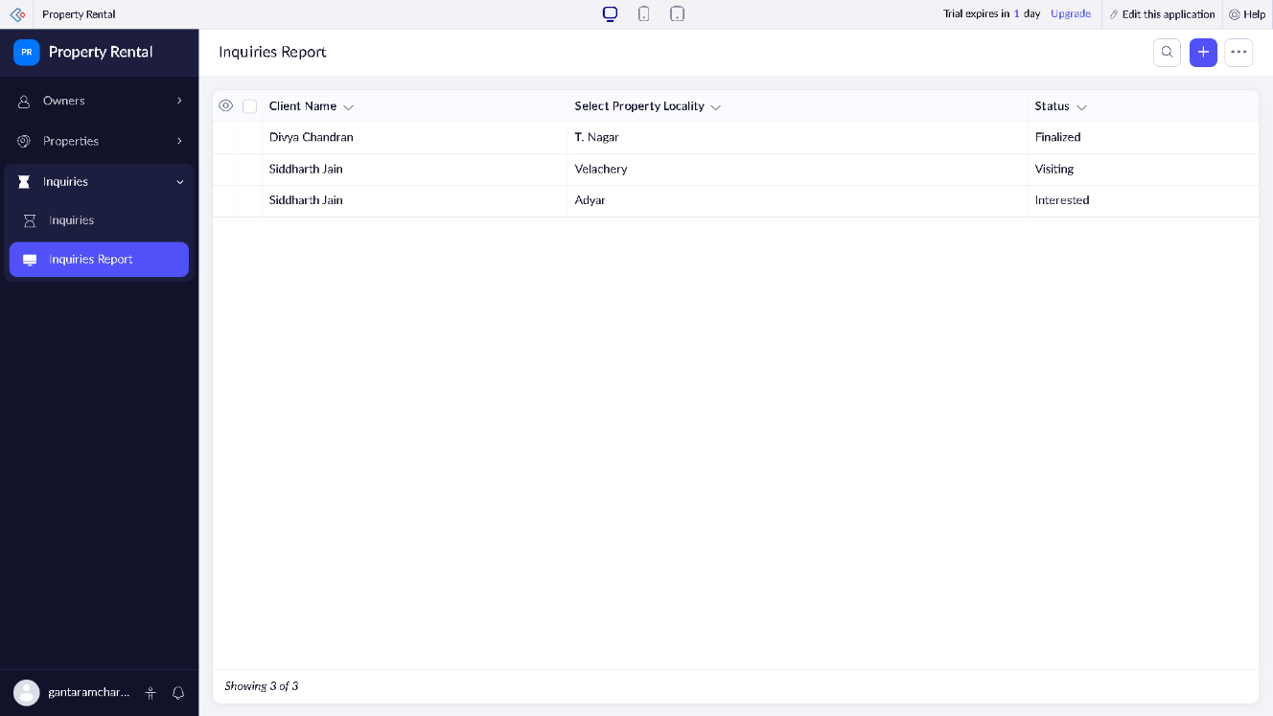

RESULT:
A relational cloud-based Property Buying & Rental application was successfully developed, integrated, and deployed utilizing the Zoho Creator SaaS framework. The platform enabled centralized property data tracking and client matching via a standard web browser window without any local software installation, successfully validating the Software as a Service (SaaS) operational paradigm.

